The ‘One Laptop Per Child’ as Personal Learning Environment

**MSc in Digital Education**

**An introduction to digital environments for learning [2012-2013] [SEM 2]**

**Course Leader: Dr Siân Bayne**

**Personal Tutor: Dr Rory Ewins**

**Due Date: 5th May 2013**

**Word Count: 4114**

Daniela Cury

# Abstract

*Some governments worldwide are distributing laptops for children in public schools with the support of the educational project called ‘One Laptop Per Child’ (OLPC)[1]. The OLPC motivation is that ‘…Internet access and tools for expression (text, music, video, graphics) are the contemporary ’toys’ for learning’. As projects like the OLPC are introduced in schools, learning environments become more complex and distinctive from what the educators were taught to teach, and these changes raise concerns about the processes that underlie learning inside and outside the classroom. In this new reality, understanding the general nature of personal learning environments (PLEs) and its salient aspects become very important to motivate autonomous learning experiences amongst students, regardless the present challenges facing the education system. This paper examines some ideas on how OLPC projects introduce the concepts of PLEs to children inside and outside the classroom.*

# Introduction

We have always had a personal environment that we learn, although we may not have been aware of it and we have not needed to be, especially because the teacher-expert model was more than enough to provide us with information relevant to living, even if we were still learning outside of it. Besides, sources of information were limited and fully centralized in the educational institutions.

However, with the popularization of the small wireless devices such as laptops, tablets and smart phones and, the advent of Internet technology called Web 2.0[2], things have changed. We are in an educational era that Weller (2011) calls ‘the abundance’. Now we can access quickly and easily to a huge amount of information and talk about almost anything, from different sources, with heterogeneous perspectives and multiple origins, in an incredible variety of formats. The information environment is no longer exclusive but rather inclusive. We can make all this information comes to us through a lot of ways and presented it when best suits us, on different devices, languages, manners and places of our choice. Almost everything that might interest us is a click away on a computer. This means that the experiences, exchanges and activities that the use of technology has allowed us has extraordinarily increased, diversified and can also be customized according to our learning styles, to the point that learning environments centralized and common to all seem insufficient and impoverishing.

The challenge is no longer to access information and supporting tools. It becomes to filter and learn how to use them in the way that matters for effective learning. In this new context, not all the conditions necessary to leverage learning using the information and communication technologies (ICTs) are in place, for example, many of the existing educators do not have enough understanding and abilities towards the ICTs to apply them into the learning environment. The same can be said about many education leaders, policymakers and higher education institutions that prepare new educators for the field.

This gap in technology understanding influences school’s program and curriculum development. ‘Too often, this gap prevents technology from being used in ways that would improve instructional practices and learning outcomes’ (U.S. Department of Education 2010).

Papert (1980) suggested that, although children do not need coaxing to take up digital technologies and, their skills quickly improve relative to their elders, without guidance most of the students will remain amateur users of the ICTs. This raises concerns about how these children will develop their knowledge because they are not fully digitally literate, yet are immersed in the digital world. In this panorama, children might not benefit either from traditional education - because there are a lot of distractions and time wasted to embed the laptops in the classroom activities (Fang 2009), or from technology – because these children will not receive adequate guidance on how learn to learn in the digital age (Cristia et al. 2012).

Consequently, it is imperative that technology plays a role beyond the mere information-diffusion and helps children learn to learn. This implies that technology must help children to tailor their PLEs whether in formal, informal, permanent or self-regulated learning/education.

As a research topic, this paper analyses the general nature of PLEs and the OLPC foundation to verify how these two concepts are intertwined. The principal aim was to understand how OLPC projects can introduce some salient aspects of PLEs to children through a customized laptop and its learning platform and thus, help leverage autonomous learning experiences regardless the present challenges facing the education system.

The paper is organized as follow: section 1 explores the most salient aspects of PLE that can be found in the literature. The section 2 describes the foundations of the OLPC project. The section 3 introduces the OLPC laptop as a PLE for children, presents the OLPC laptop hardware features and the test drive of its learning platform. Finally, the section 4 draws conclusions on how OLPC introduces the concept of PLE to children inside and outside the classroom.

1. What is a Personal Learning Environment (PLE)?

The PLEs are not a theory of teaching, but rather it can be perceived as a set of artefacts, cognitive processes, tools and physical connections gathered by individuals that allow controlling and managing their learning process. The theoretical foundations on which to base the use of PLEs depend in great extent on the perspective in which this approach will be introduced. The concept itself is still developing and thus there are a number of definitions, which vary slightly from author to author. One of the first conceptualizations of PLE is found in the ‘VLE[3] of the future’ (Wilson 2005), although the term itself already appears in ‘Lifelong Learning: The Need for Portable Personal Learning Environments and Supporting Interoperability Standards’ (Olivier and Liber 2001).

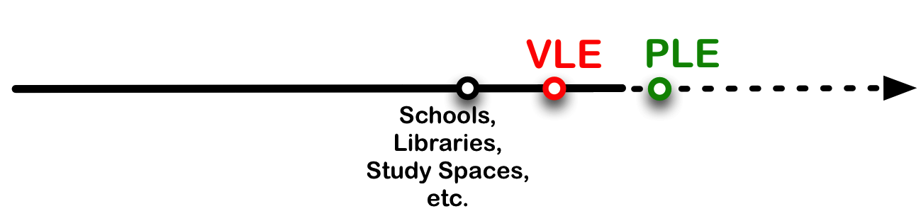

Figure 1: Metaphor for learning spaces development

The following description proposed by Stephen Downes is intended to introduce the general nature of PLEs:

…not an institutional or corporate application, but a personal learning center, where content is reused and remixed according to the student's own needs and interests. It becomes, indeed, not a single application, but a collection of interoperating applications---an environment rather than a system. It also begins to look like a personal portfolio tool. The idea here is that students will have their own personal place to create and showcase their own work. (Downes 2005b)

This description captures some salient aspects of the PLEs presented below, which seem to be common across all current viewpoints found in the literature and which will guide the analyses of this paper:

Personal and Global

The PLEs are not tight to an institutional portal like the VLE but instead, the **learning experiences are centred in the individual** and he/she **controls** its own PLE (i.e. **autonomy and ownership)**. As Wilson et al (2007) pointed out, the PLE is considerate personal and operates in a global scope as the range of services is not restricted within any particular organization.

Aggregation

One of the side effects of **Web 2.0** is the large number of services and tools available. Users spend a lot of time trying new services, creating accounts, profiles, user names and passwords, and adding them to their growing and dynamic **digital identity.** This situation can create disorder, confusion and distraction for the average learner. To work around these constrains, Attwell (2007) suggested that a PLE should provide a framework and tools to facilitate the use and aggregation of different services. The PLEs can help users to concentrate and manage all services from a single point. Technically, the PLEs should act as a hub of content related to the learning experience of a single person. Some metaphors for PLEs as an aggregator: ‘**personalized dashboard’** or **‘online learning desk’**.

Space

As we move into a world where information is fragmented and dispersed in multiple spaces **(i.e. decentralized information)**, formats are shaped by the technology and ‘…learning will take place in different contexts and situations and will not be provided by a single learning provider’(Attwell 2007)**.**

Collaboration

Collaboration is an important skill to encompass the diversity of knowledge available in a rapid changing and sophisticated society. Its essence is directly linked with the assumptions of the PLEs because learners can test their knowledge, receive feedback on their works and scaffold their learning by collaborating and exchanging information. It has always been possible to collaborate, but the Web 2.0 and its social tools (such as blogs, Wikis and all kinds of different personal knowledge databases including bookmarks and tags) have added a new dimension to the concept of collaboration by **empowering learners** to become producers of learning material (Attwell 2007). Now it is easier, cheaper and faster to work with peers and experts regardless of time zone or physical distance.

Flow

As the individual become the centre of the PLE, he/she can personalize its own learning environment reflecting his/her learning moods, styles (visual, auditory or kinaesthetic) and learning experiences. Indeed, these intrinsic interactions around his/her own learning events can facilitate the **embodiment** of ‘the holistic experience that people feel when they act with total involvement – as flow’ (Csikszentmihalyi 1975, p.36).

Digital identity & Identity

While the individuals build, expand and manage their PLEs, they also gain experience in developing their own personal and professional identity (i.e. **personal portfolio)**. As they gain experience in a number of skills related to identity in the online environment, they also strengthen the network that supports a large part of their learning. Dabbagh and Kitsantas (2012) affirm that the learner develops an online identity where the personalized learning environment provides cues (affordances or possibilities for action) that prompt the learner about what to share, what not to share, who they choose to share with, and how to effectively merge formal and informal learning.

Connectivism

Connectivism is defined as a learning theory for the digital age that underlines the use of the opportunities offered by technology to enrich formal and informal learning (Siemens 2005; Downes 2005a). Siemens has formulated the principles of connectivism proposing that:

* Learning and knowledge rests in diversity of opinions.
* Learning is a process of connecting specialized nodes or information sources. Learning may reside in non-human appliances.
* Capacity to know more is more critical than what is currently known
* Nurturing and maintaining connections is needed to facilitate continual learning.
* Ability to see connections between fields, ideas, and concepts is a core skill.
* Currency (accurate, up-to-date knowledge) is the intent of all connectivist-learning activities.
* Decision-making is itself a learning process. Choosing what to learn and the meaning of incoming information is seen through the lens of a shifting reality. While there is a right answer now, it may be wrong tomorrow due to alterations in the information climate affecting the decision (Siemens 2005).

Below is a list of some others aspects embedded in the PLEs that are also important to underline:

* Learning experiences are centred in the individual.
* Control: Individuals are the responsible for their personal information.
* Autonomy.
* Ownership.
* Web 2.0 tools.
* Online learning desk.
* Decentralised information.
* Embodiment.
* Personal portfolio.
* Empowering learners.

1. Foundations of the One Laptop Per Child (OLPC)

Inspired by the educational ideas of Jerome Bruner[4] and Seymour Papert[5] to create an autonomous personal-computer for children of all ages, the OLPC Project aims to ‘empower the world’s poorest through education’ ('OLPC Mission' n.d.), by providing each child with a collaborative and joyful laptop that could engage children in their own education. Thus, talk about OLPC is to discover new uses and combinations for technologies to address old concerns such as Education for All (EFA)[6] and, universal access to information and knowledge (UNESCO n.d.).

The OLPC hypothesis is that children can unlock the potential that they have with a personal learning device with them at all times. This idea also conforms to Attwell (2007) visions that ubiquitous computing may offer new opportunities for learning. Therefore, if each child owns its own laptop (the OLPC laptop called XO), this would enable a more learner centred approach as an alternative to the traditional instructional approach focused on trainers' needs, which in many places is affected by deprivation, physical isolation, cultural and political barriers.

The OLPC project has a view of learning known as constructionist learning, a philosophy inspired by Jean Piaget’ constructivism[7]model (Attwell 2007) where the children act as the builders of their own intellectual structures to understand the world around them (Papert 1980).

The collaborative and joyful aspects of the laptop to engage children in their own education are indeed good examples to differentiate Piaget's constructivism and Papert’s constructionism, as described by Papert himself:

My little play on the words construct and constructionism already hints at two of these multiple facets--one seemingly ‘serious’ and one seemingly ‘playful.’ The serious facet will be familiar to psychologists as a tenet of the kindred, but less specific, family of psychological theories that call themselves constructivist. Constructionism--the N word as opposed to the V word--shares constructivism's connotation of learning as ‘building knowledge structures’ irrespective of the circumstances of the learning. It then adds the idea that this happens especially felicitously in a context where the learner is consciously engaged in constructing a public entity…(Papert and Harel 1991).

## 2.1. OLPC’s Five Principals

Wherever the XO laptops are distributed, there are five core principals that must be respected for the correct implementation of the OLPC project ('OLPC Principles' n.d.):

1. **Child Ownership:** Children should stay with the laptops. They ‘should be free to take them home and use at the time they wish’ ('OLPC Principles' n.d.). When children have their own machine, they will not treat the laptop as government property, but as a personal item and a valuable gift that needs to be protected. Taking the machines home generates additional learning opportunities for children and learning becomes a central point in their lives.
2. **Low Ages:** The XO is designed for use by children between the ages of 6-12 years, covering the years of primary school, but nothing prevents its use earlier or later stages. Children do not need to read or write in order to play with the XO and according Papert (1980), playing is an essential foundation of human learning. In addition, these digital activities help acquiring mathematical skills, scientific, reasonable thinking, reading and writing.
3. **Saturation:** To achieve a significant improvement in education, access to a means of personal expression and knowledge should be a right rather than a prize. Therefore, provide equal opportunity to all citizens of the same community, state or country is a key point of the project referred as ‘Nobody is left out’ ('OLPC Mission' n.d.). The saturation also helps in the issue of security. As each child has its own laptop and communities feel part of this initiative, there is less envy, hence, less incentive for theft.
4. **Connection:** The XO has been designed to provide the most effective wireless network, even without local Internet. Children in any neighbourhood are interconnected in a wireless mesh to chat, share information, join videoconferences and work together to create music, edit papers, read books and play games online. The connectivity removes artificial barriers for learning and development. Children can communicate across borders in a way that few years ago were simply not possible.
5. **Free and Open Source:** By choosing a free and open source platform, there is no inherent external dependency or restrictions on redistribution, software choice, licensing and upgrades costs and, local language localization to fit their needs. The children and their communities should be free to choose.
6. The OLPC project and the PLE

To attain the five OLPC’s principles, the project fundamentally reconsidered personal computer architecture—hardware, software, and display – to develop an innovative computer at the lowest price and best quality available, respecting a set of design goals ('XO Laptop' n.d.) identified in order as safety, low power consumption, low cost, robustness and high performance.

## 3.1. The XO laptop

The resulting machine, says its creator Yves Behar (2007), is a green and small laptop that can operate in the harshest conditions, where each part that makes up it is strategically planned to give the best performance, robustness and quality. For economy and efficiency purposes, every part of the XO laptop has two, three or more different functions. Such characteristics make the XO laptop very effective to work with children that usually walk to and from school every day; where the weather is unpredictable, and rain, dirt and dust are part of their daily routine. Yves also observes that the XO is not a cost-reduced version of today's laptop, which is normally second-rate, second-hand and low quality; it is a whole new concept of children’s laptop.

Among the XO’s features are the two Wi-Fi antennas, which provide the ability to connect the laptops to chain together to form a mesh network to connect to distant Internet signal and relay it to the others laptops. The screen made to operate both indoors and outdoors can flip around, allowing for its use as an e-reader or a touchscreen[8] tablet without a keyboard. The battery that consumes ten times less energy that a standard laptop (it should last the entire school day without requiring charging) and can be charged by hand with a separate crank charger (this feature is only possible because the XO consumes very little energy). The colour, shape and size of the laptop, bright and playful with a tiny keyboard, emphasize its ownership by children and help detour theft. The XO also carries a webcam, microphone, two speakers, SD card reader, three USB ports and multiple types of game console buttons.

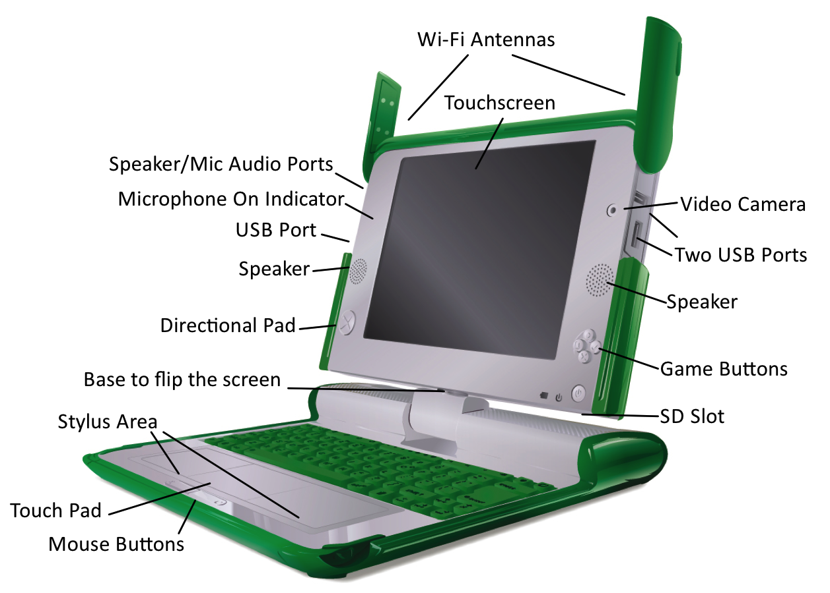

Figure 2: XO Laptop hardware features

## 3.2. The XO as PLE

As suggested previously in this paper, an ideal PLE aggregates a collection of interoperating applications for learning in a single and personalized dashboard. Children involved in the OLPC project have access to a learning dashboard in which case is called Sugar platform.

One of the objectives of Sugar platform is to encourage each child to become a creative force within the community and its own culture. Papert (1980) suggests that learning is not a passive service such as watching television but rather an active and self-direct service. Hence, the creativity, fluidity, innovation and problem solving involve personal expression and interaction. Combined, the XO hardware features and the Sugar platform, the OLPC project puts the tools of expression to the reach of children and promotes collaborative learning that can be shared with a single click.

## 3.3. The PLE embedded into the Sugar Platform

This subsection provides a brief insight of the Sugar platform test drive performed using three PC laptops running ‘Sugar on Stick’[9]. The aim of this experiment was to examine a real installation of the Sugar platform and evidence some of the salient aspects about PLE discussed previously in this paper.

Personal and Global - Learning experiences are centred in the individual

The very first impression is that all Sugar interfaces are simple and intuitive, although they differ substantially from the traditional Desktop metaphor used in other operational systems such as Windows and MacOS. Sugar uses a ‘zooming’ metaphor, where each view represents a different scale of interaction with the child’s icon always located at the centre of the screen.

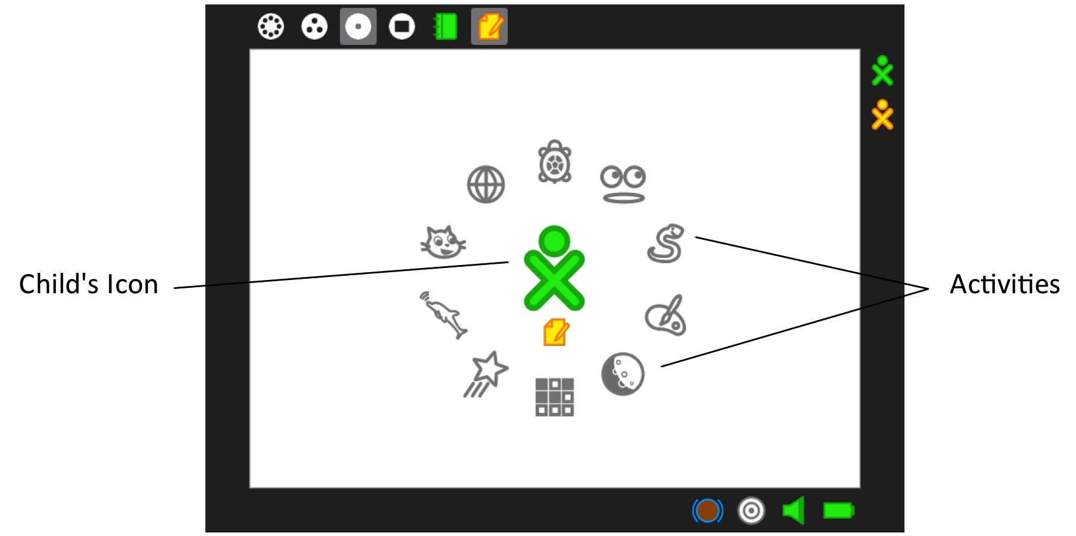

Figure 3: View of 'Home' showing the child's icon in the centre of the 'Activities'

Aggregation and Space

The first view presented at the start up is ‘home’ where the icons represent the child and his/her favourite activities. From there, the child can zooming into the currently open application called ‘Activity’ or, zooming out one step to the ‘groups’ view, where he/she can also see friends, classmates, and any other groups to which the child belongs and their activities. Zooming out one more step, the child reaches the ‘neighbourhood’ view, where he/she can see everyone in his/her local mesh, grouped around current active activities. This interesting view brings a visual representation of the popularity of an activity that is noticed according to the size of the group.

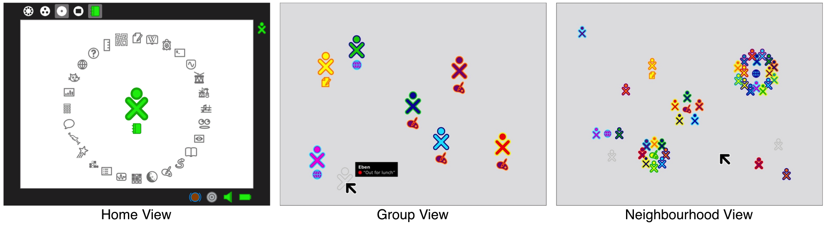

Figure 4: The distinct zoom levels of the ‘Places

Another experience that particularly characterizes the Sugar platform is the absence of a menu bar or ‘other form of persistent interface element’ ('OLPC Human Interface Guidelines' n.d.). Sugar uses ‘frames’ to aggregate all the important information and relevant tools that a child might need across all views. The left, top and right regions of the frame aggregates respectively objects, places and people. The bottom of the frame aggregates activities, invitations, and notifications. The left region serves as temporary storage for ‘Objects’ that in the case of the Sugar platform are documents, pictures, notes, links, etc. This organization facilitates their transfer among activities and the various zoom views. The top region is used to move across ‘Places’, i.e. Activity, Home, Groups, and Neighbourhood views. The right region provides a quick reference about the ‘People’ the child is working with, which updates as new people join and others leave.

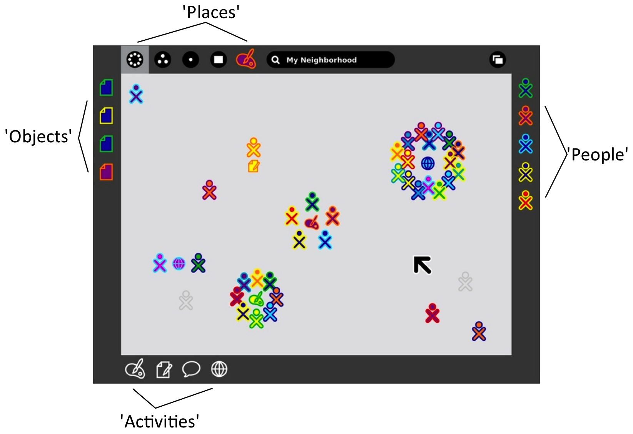

Figure 5: Organization of the information and tools in the frame

Collaboration and Flow

The mesh network that interconnects all laptops within range enables social interaction and collaborative learning similar to the Web 2.0 tools. This feature combined with the ‘Places’ views of the children ‘Groups’ and ‘Neighbourhoods’ adds an additional sense of community that probably will encourage the child to exchange ideas and collaborate with peers, making the learning process more engaging and stimulate critical thinking. This allows direct internalization of ideas in any area that the child is exploring whether music, reading, writing, programming or graphic design.

Another interesting way to explore a new subject while exchange ideas in the Sugar platform is through the ‘Bulletin Board’, which provides a ‘spatially contextual chatting interface’ ('OLPC Human Interface Guidelines' n.d.). This means that, children involved in the same project can chat and position their messages directly above any view on screen around specific areas of the activity.

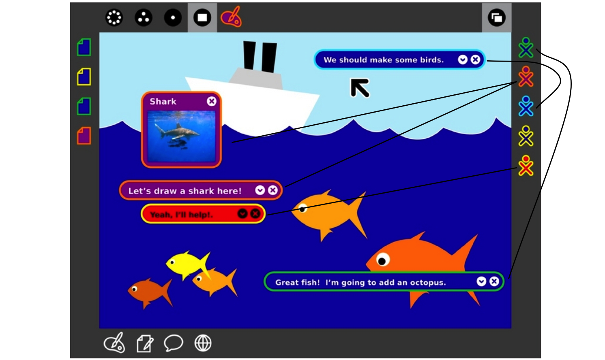

Figure 6: Collaborative activity showing 'Spatial Contextual Chatting'

Digital identity and Connectivism

The ‘Journal’ records automatically all things a child has done, or, more specifically, the activities a child has participated, in a chronological order. The contents of the ‘Journal’ create a portfolio of the child's interactions with the machine that can be revisited for reflection, association, progress evaluation and sharing. It is a continual process of scaffolding the child learning experiences, an indication of the connectivism approach embodied in this platform.

1. Conclusion

The conceptualization of PLEs and the development of the OLPC project emerged around the same period (2005), inspired by the some constructivism and connectivism ideas and, the use of ICTs in education. Consequently, both concepts are oriented towards the individual’s innate capacity to learn, share and pursue new ideas, content, resources and tools they need to leverage autonomous learning experiences using a computer.

By given children they very ‘own’ and ‘connected’ laptop ('OLPC Principles' n.d.), the OLPC project also furnishes these children with a ‘cognitive artefact’ (Papert 1980), which not only fits perfectly with the concept of a PLE but also enhance its domain, adding flexibility for learning.

In practice, children involved in the OLPC project have full time access to a personal tool for creation, reflection, expression and communication, where the learning experiences are recorded automatically and can be revisited at any time. To enable collaborative learning through a social environment similar to the Web 2.0 tools, whether the child has or not Internet access, the XO laptop provides access to a mesh network that interconnects all XO laptops within range. Thus, children can exchange ideas and participate in collaborative projects encouraging critical thinking. These possibilities make the learning experience more attractive and intense because they require the child capacity of merging formal and informal learning, inside and outside the classroom.

# References

Attwell, G. (2007). Personal Learning Environments - the future of eLearning? *eLearning Papers*, 2(January), pp.1–8. [online]. Available from: <http://www.elearningeuropa.info/files/media/media11561.pdf> [Accessed April 28, 2013].

Behar, Y. (2007). Yves Behar on Designing OLPC. [online]. Available from: <http://www.youtube.com/watch?v=Q-P5LsFfaro> [Accessed May 5, 2013].

'Constructivism', *Wikipedia*. [online]. Available from: <http://en.wikipedia.org/wiki/Constructivism_(learning_theory)> [Accessed April 26, 2013].

Cristia, J.P. et al. (2012). Technology and Child Development: Evidence from the One Laptop per Child Program. *Inter-American Development Bank*. [online]. Available from: <http://idbdocs.iadb.org/wsdocs/getdocument.aspx?docnum=36706954>[Accessed May 3, 2013].

Csikszentmihalyi, M. (1975). *Beyond Boredom and Anxiety*. First Edit. San Francisco: Jossey-Bass. [online]. Available from: [http://psy2.ucsd.edu/~nchristenfeld/Happiness_Readings_files/Class 7 - Csikszentmihalyi 1975.pdf](http://psy2.ucsd.edu/~nchristenfeld/Happiness_Readings_files/Class%207%20-%20Csikszentmihalyi%201975.pdf) [Accessed May 2, 2013].

Dabbagh, N. and Kitsantas, A. (2012). Personal Learning Environments, social media, and self-regulated learning: A natural formula for connecting formal and informal learning. *The Internet and Higher Education*, 15(1), pp.3–8. [online]. Available from: <http://linkinghub.elsevier.com/retrieve/pii/S1096751611000467> [Accessed March 2, 2013].

Department of Education (2010). Principles of Connected Teaching. (U.S.A.)[online]. Available from: <http://www.ed.gov/technology/draft-netp-2010/principles-connected-teaching>[Accessed May 4, 2013].

Downes, S. (2005a). An Introduction to Connective Knowledge. *Stephen Downes Blog*. [online]. Available from: <http://www.downes.ca/post/33034> [Accessed April 21, 2013].

Downes, S. (2005b). E-learning 2.0. *eLearning Magazine*. [online]. Available from: <http://elearnmag.acm.org/featured.cfm?aid=1104968> [Accessed April 24, 2013].

Fang, B. (2009). From Distraction to Engagement: Wireless Devices in the Classroom. *Educause*. [online]. Available from: <http://www.educause.edu/ero/article/distraction-engagement-wireless-devices-classroom> [Accessed April 22, 2013].

'Jerome Bruner', *Wikipedia*. [online]. Available from: <http://en.wikipedia.org/wiki/Jerome_Bruner> [Accessed May 1, 2013].

Olivier, B. and Liber, O. (2001). Lifelong learning: The need for portable personal learning environments and supporting interoperability standards. *Centre for Learning Technology, University of Wales Bangor*. [online]. Available from: <http://ssgrr2002w.atspace.com/papers/14.pdf> [Accessed May 2, 2013].

'OLPC Human Interface Guidelines', *OLPC Foundation*. [online]. Available from: <http://wiki.laptop.org/go/OLPC_Human_Interface_Guidelines> [Accessed April 20, 2013].

'OLPC Mission', *OLPC Foundation*. [online]. Available from: <http://laptop.org/about/mission> [Accessed April 27, 2013].

'OLPC Principles', *OLPC Foundation*. [online]. Available from: <http://wiki.laptop.org/go/OLPC:Five_principles> [Accessed April 23, 2013].

'One Laptop Per Chield', *Wikipedia*. [online]. Available from: <http://en.wikipedia.org/wiki/One_Laptop_per_Child> [Accessed April 25, 2013].

Papert, Seymour. (1980). Mindstorm. *Basic Book, New York*. [online]. Available from: <http://www.arvindguptatoys.com/arvindgupta/mindstorms.pdf> [Accessed April 9, 2013].

Papert, Seymur and Harel, I. (1991). Constructionism. In *Constructionism*. New York: Ablex Publishing Corporation. [online]. Available from: <http://www.papert.org/articles/SituatingConstructionism.html> [Accessed May 4, 2013].

'Seymur Papert', *Wikipedia*. [online]. Available from: <http://en.wikipedia.org/wiki/Seymour_Papert> [Accessed April 28, 2013].

Siemens, G. (2005). Connectivism: A Learning Theory for the Digital Age. *Elearnspace*. [online]. Available from: <http://www.elearnspace.org/Articles/connectivism.htm> [Accessed April 15, 2013].

'Education for All (EFA)', *UNESCO*. [online]. Available from: <http://www.unesco.org/new/en/education/themes/leading-the-international-agenda/education-for-all/> [Accessed March 25, 2013a].

'Universal Access to Information and Knowledge', *UNESCO*. [online]. Available from: <http://portal.unesco.org/ci/en/ev.php-URL_ID=19488&URL_DO=DO_TOPIC&URL_SECTION=201.html> [Accessed March 26, 2013b].

'Web 2.0', *Wikipedia*. [online]. Available from: <http://en.wikipedia.org/wiki/Web_2.0> [Accessed May 2, 2013].

Weller, M. (2011). A pedagogy of abundance. *Spanish Journal of Pedagogy*, pp.233–236. [online]. Available from: <http://oro.open.ac.uk/28774/2/BB62B2.pdf> [Accessed May 5, 2013].

Wilson, S. (2005). The VLE of the Future. *Scott’s Workblog at CETIS (Centre for Educational Technology and Interoperability Standards)*. [online]. Available from: <http://zope.cetis.ac.uk/members/scott/blogview/index-entry=20050117150356.html> [Accessed April 6, 2013].

Wilson, S., Johnson, M. and Sharples, P. (2007). Personal Learning Environments : challenging the dominant design of educational systems . *Je-LKS - Journal of e-Learning and Knowledge Society*, 3(2), pp.27–38. [online]. Available from: <http://ubir.bolton.ac.uk/index.php?action=fileDownload&resourceId=289&hash=0382c207c66a9834d4390e0f2be6ed3c52e718e5&filename=iec_journalspr-9.pdf> [Accessed April 29, 2013].

'XO Laptop', *OLPC Foundation*. [online]. Available from: <http://wiki.laptop.org/go/Hardware> [Accessed May 3, 2013].

1. One Laptop per Child (OLPC) is a project supported by the Miami-based One Laptop per Child Association (OLPCA) and the Cambridge-based OLPC Foundation (OLPCF), two U.S. non-profit organizations established in January 2005 by Nicholas Negroponte ('One Laptop Per Chield' n.d.)
2. The next generation of Internet applications and the underlying technologies that enable conversations and contribution to the online community. Examples of Web 2.0 include content sharing (video, photo, etc), social networking sites, blogs, wikis and mashups ('Web 2.0' n.d.).
3. Virtual Learning Environment
4. Jerome Seymour Bruner (born October 1, 1915) is a psychologist who has made significant contributions to human cognitive psychology and cognitive learning theory in educational psychology ('Jerome Bruner' n.d.).
5. Seymour Papert (born February 29, 1928) is an MIT mathematician, computer scientist, and educator. He is one of the pioneers of artificial intelligence, inventor of the Logo programming language and the developer of an original and highly influential theory on learning called constructionism ('Seymur Papert' n.d.).
6. The Education for All (EFA) movement is a global commitment to provide quality basic education for all children, youth and adults (UNESCO n.d.).
7. Constructivism is a theory to explain how knowledge is constructed in the human being when information comes into contact with existing knowledge that had been developed by experiences ('Constructivism' n.d.)
8. A touchscreen feature was included in the prototype XO-2.
9. A flash drive version of Sugar Learning Platform that can be loaded at any computer at any time. The link for download is: http://wiki.sugarlabs.org/go/Downloads